**References**

1. Introduction to Stepper Motors. (n.d.). Retrieved October 6, 2014, from <http://www.omega.com/prodinfo/stepper_motors.html>
2. RobotShop | Robot Store | Robots | Robot Parts | Robot Kits ... (n.d.). Retrieved October 1, 2014.
3. SparkFun Electronics. (n.d.). Retrieved September 29, 2014.
4. Firgelli Technologies - Micro Linear Actuators. (n.d.). Retrieved October 3, 2014.
5. Stepper motor|Stepping gearmotor wholesale|Stepping motor ... (n.d.). Retrieved October 2, 2014.

**Images**

Soyo SY42STH38-0406B Unipolar Stepper Motor

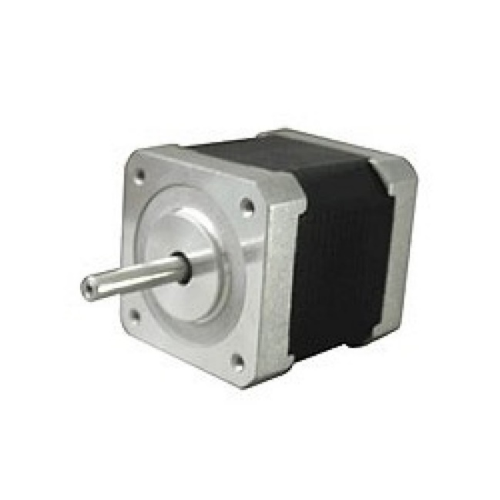

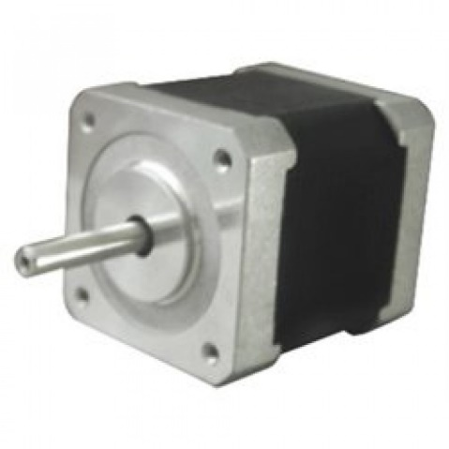Soyo SY42STH47-1684MB RepRap Stepper Motor

Wantai 42BYGHM809

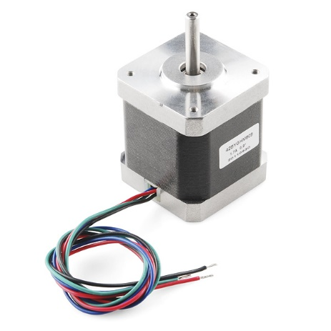

Wantai 57BYGH420

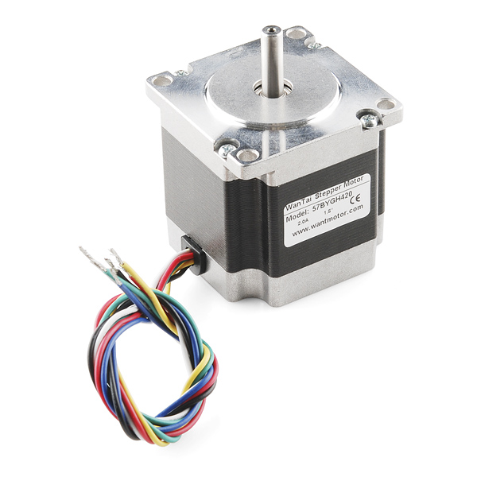

Micro Metal Gearmotor 30:1 Shenzen Kenmore KM-12FN20-30-06430

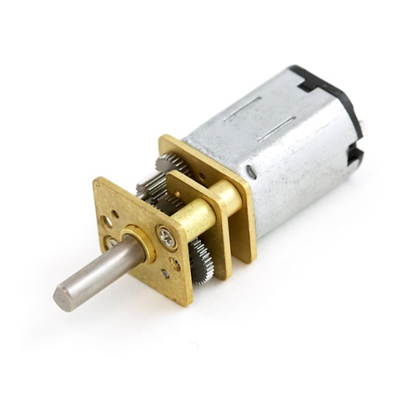

Micro Gearmotor ROB-12285

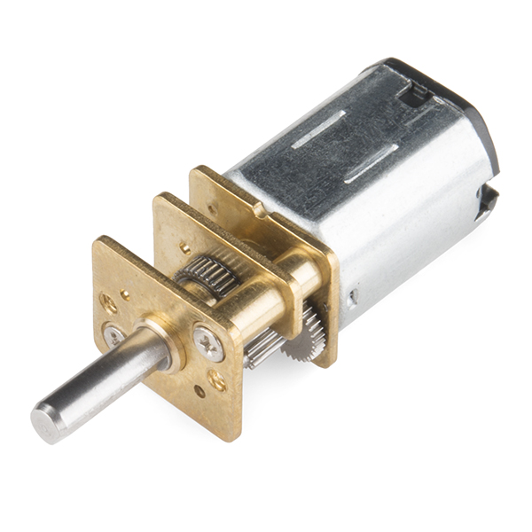

Cytron 12V 12RPM 166oz-in Spur Gearmotor

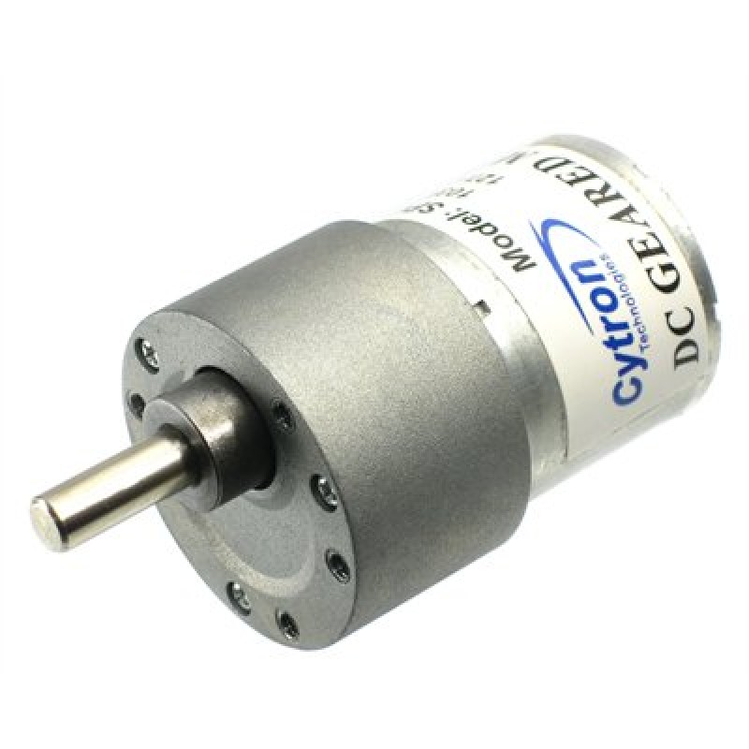

Firgelli Technologies L12 Actuator 50mm 210:1 12V Limit Switch

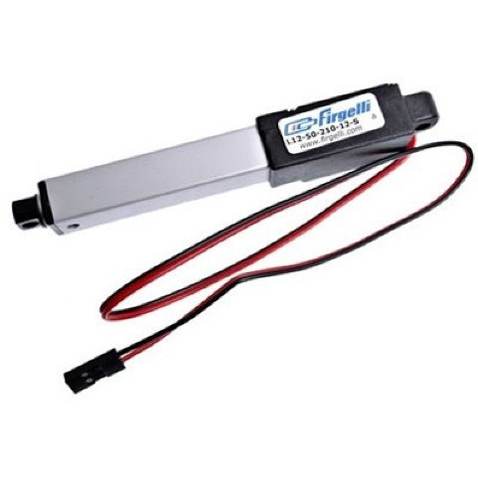

Firgelli Technologies L12 Actuator 100mm 100:1 12V Limit Switch

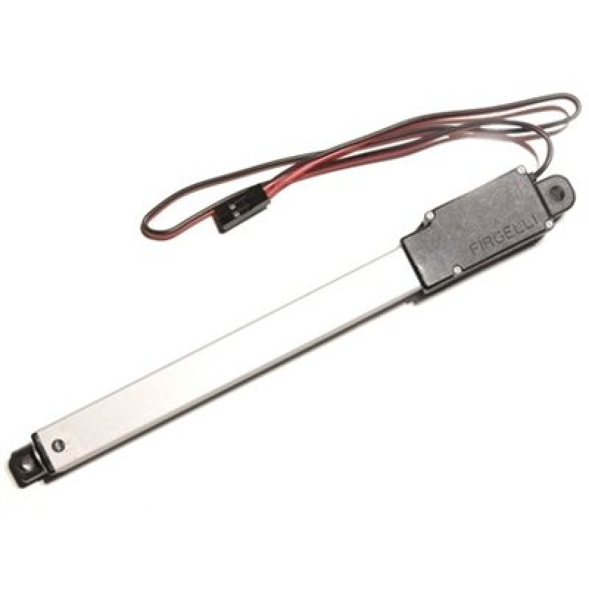

Firgelli Technologies L16 Linear Actuator, 140mm, 35:1, 12V w/ Limit Switches

